Forge is a resource builder for creating reusable learning objects (RLOs) in a web-based format. If you are already using Forge, you will know how easily the Forge editor enables you to create attractive and engaging resources.
New functionality means that you can now import Forge HTML5 resources into Brightspace. These resources can either be viewed within a frame or opened in a new tab via a button built into the resource.
- Create your learning resources in Forge
- Use Forge in the normal manner to design your learning content for a topic/session/week.
When you have completed the set of pages for this topic, export the package by clicking on the ‘Download as HTML5 resource’ icon:
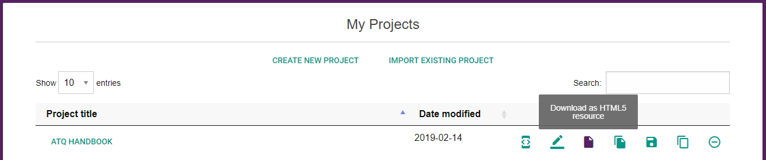

Figure 1 Click on ‘Download as HTML5 resource’ icon
- You now have a zipped package for uploading into Brightspace.
- Upload your resource to Brightspace
- Go into the Manage Files area of your course in Brightspace and press the upload button. Upload the Forge export zip and press save.
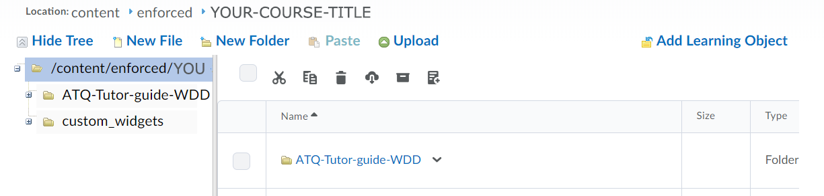

Figure 2 The upload button in Manage Files
- Click on the arrow to the right of the zipped package you have uploaded, select ‘Unzip’ and click OK on the unzip info notification dialog.

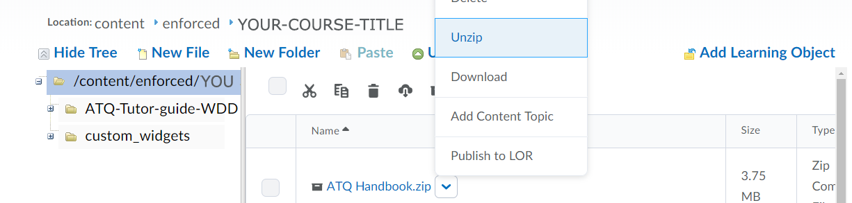
Figure 3 The unzip button
- Once unzipped you will see a folder called ‘build’ that is the folder with your HTML5 resource in it. Rename this folder to something appropriate by clicking on the arrow to the right and pressing ‘Rename’. Note - It’s good practice to keep folder names short and avoid spaces (e.g. session-1 or economics-intro) and creating folders for related content will aid future file management tasks such as updating/editing.
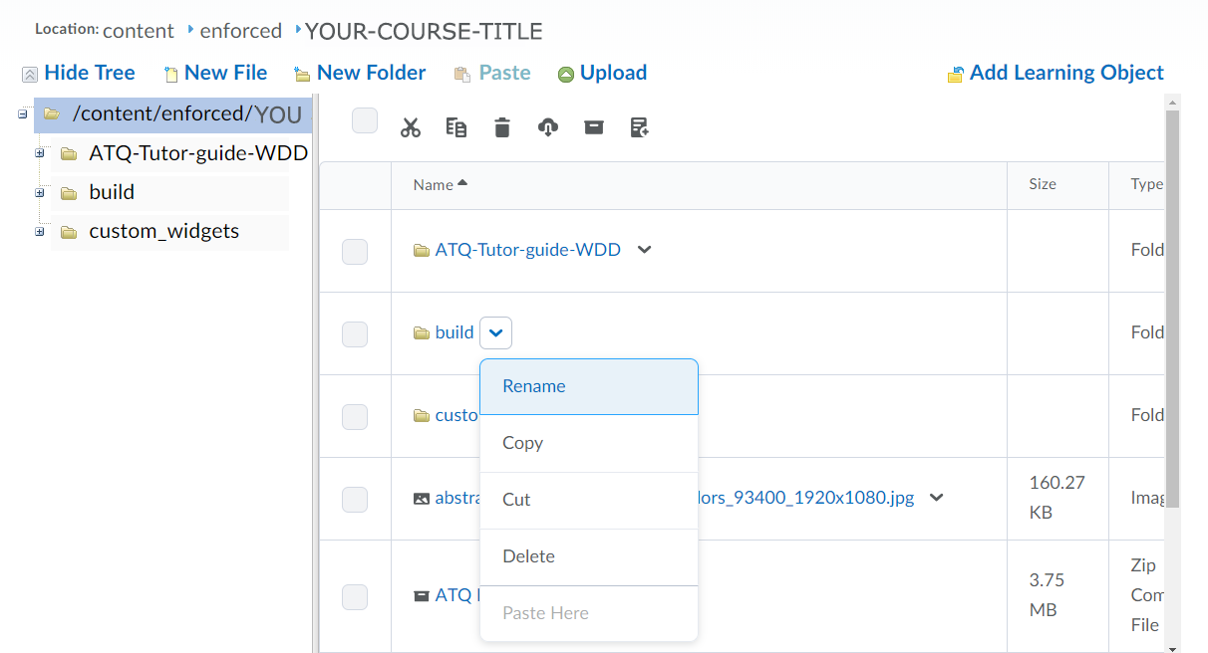

Figure 4 The rename button
- Your resource is now ready to add to the Brightspace content area. The original zipped package is still there too – you may decide to delete this, store it in an alternative location or leave where it is – that’s up to you.
- Add pages to Brightspace content area
- In the appropriate content area of your course, click on the Upload/Create button and select ‘Add from Managed Files’.
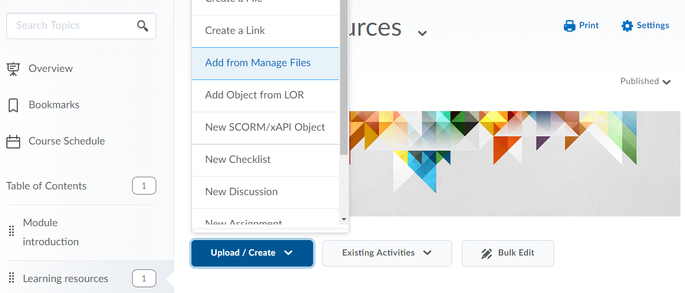

Figure 5 Add from manage files button
- Navigate to the folder, select the ‘index.html’ page and click Add
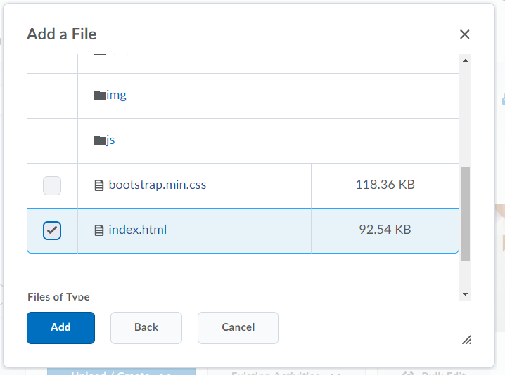

Figure 6 Select the ‘index.html’ page and click Add
- This will create a page in your module called ‘index’. Feel free to rename this to something more appropriate. To do this click into the page by pressing the heading. This will open up the resource. At the top of the page you will see the heading ‘ index’. Click the arrow to the right of this and select ‘Edit Title’.
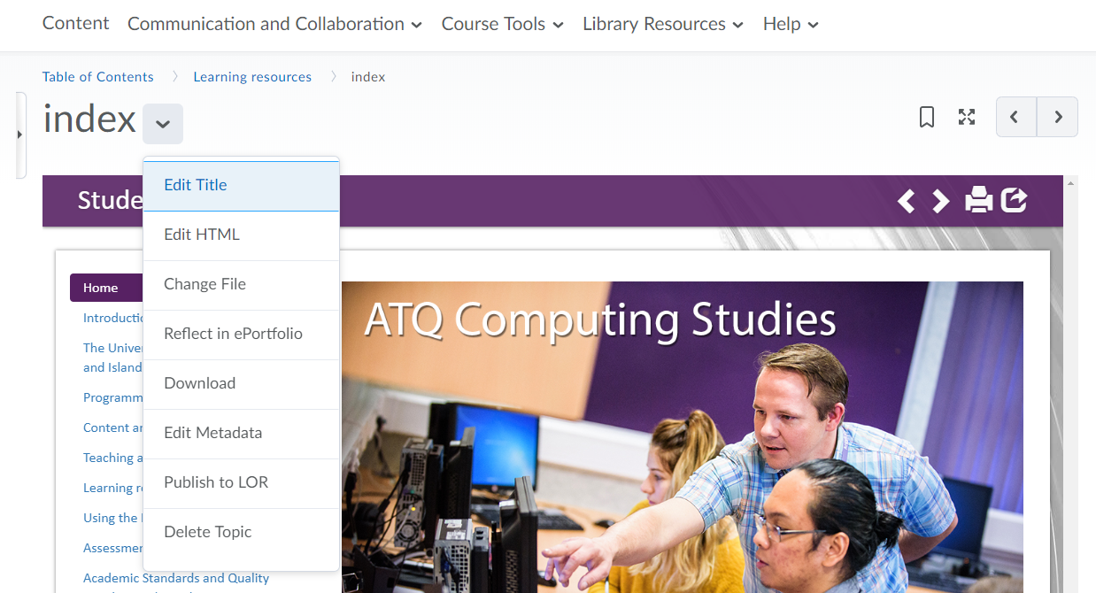

Figure 7 Add from manage files button
- Your resource has now been added into Brightspace. You can open it in a new tab using the button highlighted below.
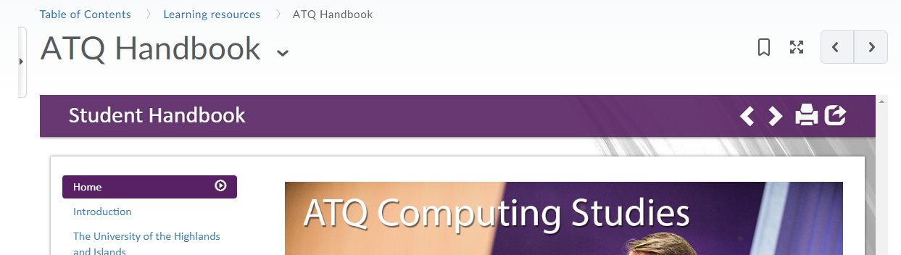

Figure 8 ‘Open in a new tab’ button

